Absolute Phrase as a modifier

🔹 What Is Absolute Phrase as a modifier?
# Source: AI Source: Provided by: [Data Path: Persons Table -> ID Column: 1, Name_En Column: Motasem Essam] -> From: [Chatgpt (GPT‑5 Mini)] on [8/7/2025]
An absolute phrase (also called a nominative absolute) is a group of words that modifies the entire sentence, not just a single word.
It usually consists of a noun or pronoun followed by a participle (present or past) and its modifiers or objects.

🔸 Structure:
# Source: AI Source: Provided by: [Data Path: Persons Table -> ID Column: 1, Name_En Column: Motasem Essam] -> From: [Chatgpt (GPT‑5 Mini)] on [8/7/2025]
[Noun or Pronoun] + [Participle] + [Modifiers/Complements]
Note: It does not contain a finite verb and is not grammatically connected to the main clause.

🔸 Function:
# Source: AI Source: Provided by: [Data Path: Persons Table -> ID Column: 1, Name_En Column: Motasem Essam] -> From: [Chatgpt (GPT‑5 Mini)] on [8/7/2025]
Adds background detail or context — such as time, cause, condition, or circumstance — to the entire sentence.

🔸 Examples:
# Source: AI Source: Provided by: [Data Path: Persons Table -> ID Column: 1, Name_En Column: Motasem Essam] -> From: [Chatgpt (GPT‑5 Mini)] on [8/7/2025]
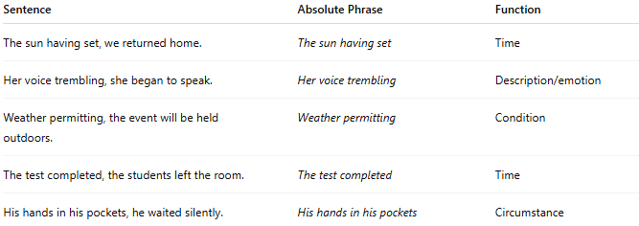
Sentence | Absolute Phrase | Function
The sun having set, we returned home. | The sun having set | Time
Her voice trembling, she began to speak. | Her voice trembling | Description/emotion
Weather permitting, the event will be held outdoors. | Weather permitting | Condition
The test completed, the students left the room. | The test completed | Time
His hands in his pockets, he waited silently. | His hands in his pockets | Circumstance

🔸 Important Notes:
# Source: AI Source: Provided by: [Data Path: Persons Table -> ID Column: 1, Name_En Column: Motasem Essam] -> From: [Chatgpt (GPT‑5 Mini)] on [8/7/2025]
- Absolute phrases are always set off by commas.
- They do not contain a true verb (no tense).
- They act as sentence-level modifiers, providing contextual or situational information.

